Experiment No: 02
Name of the experiment: Implementing 4-bit Full adder with 4 adders.
Theory: A 4-bit Full Adder is designed to generate a 4-bit Sum and is designed by combining four 2-bit Full Adders and as a result shows the Four bits S0 S1 S2 S3 output along with the Carry Bit Cout.
Truth Table:
 | A |  |  |  | B |  |  |  | Sum
Cin | A3 | A2 | A1 | A0 | B3 | B2 | B1 | B0 | S3 | S2 | S1 | S0 | Cout
0 | 0 | 0 | 0 | 0 | 0 | 0 | 0 | 0 | 0 | 0 | 0 | 0 | 0
0 | 0 | 0 | 0 | 1 | 0 | 0 | 0 | 1 | 0 | 0 | 1 | 0 | 0
0 | 0 | 0 | 1 | 0 | 0 | 0 | 1 | 0 | 0 | 1 | 0 | 0 | 0
0 | 0 | 0 | 1 | 1 | 0 | 0 | 1 | 1 | 0 | 1 | 1 | 0 | 0
0 | 0 | 1 | 0 | 0 | 0 | 1 | 0 | 0 | 1 | 0 | 0 | 0 | 0
0 | 0 | 1 | 0 | 1 | 0 | 1 | 0 | 1 | 1 | 0 | 1 | 0 | 0
0 | 0 | 1 | 1 | 0 | 0 | 1 | 1 | 0 | 1 | 1 | 0 | 0 | 0
0 | 0 | 1 | 1 | 1 | 0 | 1 | 1 | 1 | 1 | 1 | 1 | 0 | 0
0 | 1 | 0 | 0 | 0 | 1 | 0 | 0 | 0 | 0 | 0 | 0 | 0 | 1
0 | 1 | 0 | 0 | 1 | 1 | 0 | 0 | 1 | 0 | 0 | 1 | 0 | 1
0 | 1 | 0 | 1 | 0 | 1 | 0 | 1 | 0 | 0 | 1 | 0 | 0 | 1
0 | 1 | 0 | 1 | 1 | 1 | 0 | 1 | 1 | 0 | 1 | 1 | 0 | 1
0 | 1 | 1 | 0 | 0 | 1 | 1 | 0 | 0 | 1 | 0 | 0 | 0 | 1
0 | 1 | 1 | 0 | 1 | 1 | 1 | 0 | 1 | 1 | 0 | 1 | 0 | 1
0 | 1 | 1 | 1 | 0 | 1 | 1 | 1 | 0 | 1 | 1 | 0 | 0 | 1
0 | 1 | 1 | 1 | 1 | 1 | 1 | 1 | 1 | 1 | 1 | 1 | 1 | 1
1 | 1 | 1 | 1 | 1 | 1 | 1 | 1 | 1 | 1 | 1 | 1 | 1 | 1

Circuit Diagram:
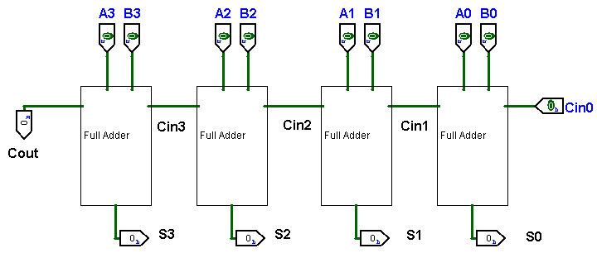
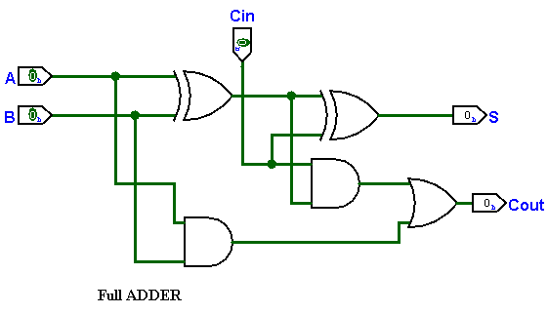

Output Screenshot:
When Then
$A0=0,B0=0$ $S0=0, S1=0, S2=1, S3=1$
$A1=1,B1=1$ $Cout=1$
$$A2=1,B2=1$$
$$A3=1,B3=1$$
$$Cin=0$$
